INTOSAI EDP COMMITTEE
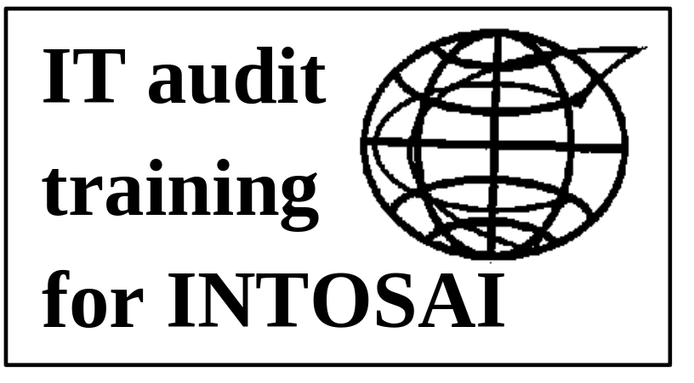
Auditing Developing Systems
Case Study
Leader’s Guide

Jan 1997
TABLE OF CONTENTS
1. Part 1: project initiation
1.1 The organisation - AEGIS
1.2 The activities of AEGIS
1.3 AEGIS development plans
1.4 Growth potential for aegis
1.5 Project FASTRAK
1.6 Member organisations of the project
1.7 The partnership programme
1.8 New technology for fastrak
1.9 Time for change
2. Part 2: business case
2.1 Background
2.2 Feasibility
2.3 Formation of project board and project team
2.4 Projected costs
2.5 Project fastrak - outline operations
2.6 Key Performance Indicators
2.7 Technology requirements
2.8 Outline project phasing
2.9 Business case
3. Part 3: the team
3.1 Project management methodology
3.2 The project manager
3.3 The Deputy Project Manager
3.4 The technology manager
3.5 The methods and process manager
3.6 The project accountant
3.7 The change co-ordinator
3.8 The software for the system - TELMO
3.9 Basic operation of the system
4. Part 4: legacy systems
4.1 Update on timetable
4.2 National accounting systems
4.3 TELMO and the user
4.4 More sub-projects
4.5 Problems with documentation
4.6 Project tensions
4.7 Politics - a possible impact on funding
4.8 Project decisions
4.9 Revised project timetable
4.10 Revised costs
5. Part 5: new technology
5.1 Update on timetable
5.2 Revised timetable
5.3 Revised costs
5.4 Difficulties with technology
5.5 New blood in the team
6. Part 6: project roll out
6.1 Update on timetable
6.2 Revised timing
6.3 Revised costs
6.4 Late but working
6.5 The end of the project?
7. Part 7: the aftermath
7.1 Update on timetable
8. Part 8: the strike
8.1 Trouble at headquarters
8.2 The strike
9. Operation of the AEGIS publication system
10. Business continuity planning

Introduction
Project FASTRAK
Project FASTRAK is the story of a Public Sector International Organisation (AEGIS) which sets out to implement a new, £ multi-million, publication sales project.
AEGIS has little experience of managing projects, and those projects it has managed before have not turned out too well.
There is a lot of pressure on AEGIS to implement this project quickly, and as a result AEGIS cuts corners. The impact is that assumptions and guesswork are used as a basis for the project rather than correctly analysed facts.
AEGIS is blithely unaware that international projects are more complex than projects conducted within a single organisation. Additionally, AEGIS is unaware of the importance of communications and co-ordination between the members of project teams.
In spite of all the problems that AEGIS faces there is a happy ending - the project is implemented and begins to bring in the returns that were expected. Overall, however, the project could have been easier, quicker, less costly and more effective, if some simple rules had been followed!
The case study
The Case study is broken down into eight Parts:
Part 1 is about AEGIS, its activities, growth and purpose, and the pressures for change facing the organisation:
- it shows studies that have been made on the organisation and that, although there is potential for growth of sales, that current customers are very unhappy about the service levels that it provides;
- CoDMIA - the executive council of AEGIS launches a new project to correct the situation - this is project FASTRAK;
- the project will be a £ multi-million multi-national effort and it will involve a partnership operation between private and public sectors;
- implementation of the project will necessarily involve some restructuring of the way that AEGIS operates.
Part 2 introduces the business case that is being made for FASTRAK:
- governments want to reduce subsidies for AEGIS;
- consultants believe that the AEGIS operation could be radically overhauled;
- a PROJECT BOARD is formed who get details about costs and benefits and who decide, on this basis, that the project will proceed;
- we are introduced to the way FASTRAK will work and the key performance targets it is expected to meet;
- we see that technology is at the heart of FASTRAK, although conventional systems are to be used;
- the team is given a short time to implement the system.
Part 3 introduces the team and their problems:
- they are having trouble on agreeing on how the project will be managed. In the end an inferior project management methodology is chosen;
- the project team are an ill matched group - competent in their own right but with a lack of experience and a lack of willingness to operate as a team;
- one of the most vital roles - that of project accountant is given to one of the least experienced members of the team and this leads to poor documentation of time, costs and targets.
In Part 3 we also see the software for the project and the way the system is intended to operate. Project FASTRAK is meant to be a conventional telephone based order and delivery system
Part 4 reveals development difficulties:
- the project hits a major snag trying to interface a software package - TELMO - to existing accounting systems - this would have been anticipated if better analysis of existing systems had been attempted before the project commenced;
- the project also encounters difficulties with TELMO because it was designed for the Swedish home market place, and all the messages and instructions are in Swedish!;
- these problems lead to an expansion of the original project, additional costs and time penalties, and put a strain on the working relationships within the project.
Part 5 reveals further problems:
- the delayed project encounters yet more problems with interfacing and a decision is made to drop some of the functions of the system;
- project documentation and change co-ordination have also deteriorated;
- further technical difficulties are encountered with the system’s network and with a bar code reading system - better hardware evaluation would have shown up these problems earlier;
- more time and cost penalties are incurred and, realising that control of sub-projects and project interfaces has become critical, the project brings in a programme director to better co-ordinate activities.
Part 6 covers implementation:
- the project finally begins to be rolled out late, over-budget, but, nevertheless working;
- a few end of project snags are encountered but the team finds ways around the difficulties.
Part 7 reveals the outcome of the project:
- financial outcomes for the key performance indicators are calculated - and, although they don’t reach the optimistic levels suggested in Part 1 - they do nevertheless show that FASTRAK is making a real and important contribution to the revenues of AEGIS - enough to class the project as a success;
- surprisingly staff costs and write off levels are much better than would have been predicted;
- sales - hit by a four month delay in the project roll - out, are a little worse than predicted.
Part 8 introduces a disaster in the form of a strike; this is used to examine the adequacy of AEGIS’ business continuity planning.
Running the case study
The study is best worked on by groups of people, for example a team comprising:
- a secretary to document results;
- a spokesperson to relay or present findings;
- other team members to debate and discuss the issues.
Delegates can either read the whole of the case study in advance or read ahead one or two Parts at a time. Allow three hours to read the whole of the study in one sitting or at least 30 minutes each for Parts 1, 2, and 3, and 20 minutes each for any of the remaining Parts if read in isolation.
The Parts of the case study can be used serially thus:
- Part 1 can be used to debate project risk;
- Part 2 can be used to debate project planning;
- Part 3 can be used to debate people issues on projects;
- Part 4 can be used to debate interfacing issues;
- Part 5 can be used to debate technical issues;
- Part 6 can be used to debate end of project issues;
- Part 7 can be used to debate value for money issues;
- Part 8 can be used to debate business resumption planning issues.
Alternatively the case study could be used in a combinatorial fashion, thus:
- Part 1 and Part 2 together can be used to debate project risk, project planning, and project management;
- Part 3 can be used to debate programme management and project direction;
- Parts 4 and 5 together can be used to debate the impact of technology on projects;
- Part 6 and 7 together can be used to debate project roll out, hand-over and value for money issues;
- Part 8 can be used as a business resumption planning exercise.
Note that Part 8 may be used entirely on its own, and out of sequence, as it includes all relevant information to be able to complete the exercise without reference to any other Part
Working instructions for delegates
The following instructions are recommended - the tutor should:
- instruct delegates to form a team comprising secretary, presenter and other members;
- tell the team which Parts of the case study they are working on;
- tell them how long they are being assigned to complete the task - this will vary according to whether they have read the material in advance;
- give them an overview of their case study Parts - use the notes in 1.2.1 above to do this - these also appear as Sheets marked “Synopsis of Fastrak” as notes for reproduction in the delegate handouts files;
- tell them to re-read and analyse the notes provided in the relevant case Parts;
- tell them what the core task is: for example “to prepare a simple business resumption plan”; “to determine what risks face the project at this stage, and state how they might be controlled”; “to determine how the interactions between members of a project team might affect the project, and state how these might be controlled”; “to determine how legacy systems or new technology might impact project plans, and state how these might be controlled”; “to determine if the project met its major objectives and goals, and if it represents good value for money”;
- tell the delegates how to document their findings, for example: as key point notes; as highlighted sections of text with hand-written explanations; or as risk and control tables as in the example below:

Reference | Risk | Impact on Project if unchecked | Control | Threat at this stage
1.4.5 | Inadequate planning | Unseen elements in project or project delays or overrun | Detailed project planning using appropriate methodology | High
This table also appears in the delegates handout files marked “Example of Risk Documentation”, and a blank table again for reproduction if working papers are needed is appended in the delegate handout files marked “Risk Documentation Blank”
At the end of the allotted time the tutor should:
- call on a team to present its findings;
- debate the findings with the presenting team, using the answer sheets provided (“Model Answers” - included part by part in the delegates handout files) and;
- distribute the model answers, if required.

Part 1: Project initiation

The organisation - AEGIS
By 1958 governments everywhere realised that one of the keys to increased export trade was knowledge, by their indigenous industries, of world standards that affected their manufacture of goods and delivery of services.
As a consequence, and as a countermeasure to a strong and growing trade imbalance between North America and the rest of the world, and inter-governmental working party was set up, between the heads of British, European and Asian countries.
The organisation AEGIS - the Asia-European Governmental Issuer of Standards - celebrated its twenty fifth birthday last year by opening a new headquarters building in Paris, France. This grand building is now the permanent home of the Chief Executive and of the Committee of Directors, International Aegis - CoDMIA.
Although the aims of AEGIS have changed from its original charter, one thing remains the same - the promotion of trade through sharing of knowledge of standards and procedures applying to overseas markets.
As at September 1996 full membership of AEGIS embraced:
- all of Europe with the exception of Holland, with whom special reciprocal arrangements apply...;
- all of Asia...;
- and all of Australasia.
With effect from the 1st March 1998, Africa will also be joining AEGIS and it is expected that South America may follow suit shortly after that. This will bring the total membership of AEGIS close to 125 countries.

The activities of AEGIS
AEGIS is represented in member countries in three ways:
- Firstly - the Minister responsible for Trade and Export is accountable for maintaining an on-going dialogue through AEGIS about trade and manufacturing standards between countries that are represented in AEGIS;
- Secondly - AEGIS has a number of outlets in each member country that sell the standards publications of all its member countries:
- in the United Kingdom in 1995, the last year for which figures are available, AEGIS sold £8 million of printed publications, more than a third of which was attributable to the re-sale of standards from overseas;
- Finally - AEGIS acts as a source of research and compiler of statistics, complementing National Statistical Offices, and providing these services on a fee paying basis to private sector organisations in member countries:
- in 1994, in the United Kingdom, the last year for which figures are available AEGIS brought in £3 million revenue from these sources

AEGIS development plans
AEGIS wants to sell more of its publications, and is looking actively at different ways of doing so. For example, a pilot trial for transferring standards to CD-ROM is underway at the AEGIS technical offices in Pipedream House, Swindon, UK.
Between 1985 and 1988 fifteen AEGIS member countries introduced a mail order service for books and reference materials using a system developed in Germany. The introduction of this service was beset by a number of technical and operational difficulties and the project overran in both cost and time. The project was abandoned in mid-1988 incurring direct losses of over £45 million. At the time AEGIS was criticised heavily for its lack of project management skills and lack of awareness of project risk.
In 1989 a simple mail order system was installed on personal computers at some AEGIS offices. This too has been abandoned.
Today, although it is possible to place telephone, personal, or mail orders for publications within all AEGIS member countries the whole of the order fulfilment process is manual. Further there is no linking of stock from one sales outlet to another, or from one member country of AEGIS to another.
The price of AEGIS publications is arrived at, as follows:
- All publications are priced, in the currency of the member country making the sale, according to the number of pages they contain;
- Value Added Tax is applied at point of sale in those countries that charge VAT on printed publications;
- A discount of 15% applies to anyone purchasing more than 25 copies of the same publication in a single order;
- Member countries classified as “Areas for Special Development” receive other members standards for re-sale, free of charge.

Growth potential for aegis
In 1994, following the AEGIS Calcutta conference, a survey was commissioned from the market research company “Etude Inter” on a 1% sample of industrial and commercial AEGIS customers in Italy, Poland and Malaysia. This showed that:
- there is further untapped demand for AEGIS publications - even existing customers were unaware of the full range of publications on offer;
- customers were very unhappy with AEGIS’s ordering system.
The primary study led to a further survey, in late 1994, again by “Etude Inter”, that showed that:
- the services provided by AEGIS are unknown to more than 50% of industrial and commercial companies;
- many companies who know of the existence of AEGIS associate it with the public sector, and have assumed that its publications are intended for public sector use only.
The conclusions drawn from the surveys were that a two-way initiative was required:
- Members of AEGIS must co-operate in an international advertising campaign to improve consumer awareness of the services on offer;
- AEGIS outlets must overhaul their order processing systems:
- following the survey, measurements were made of average order turn around times in AEGIS outlets in Lyons, France and Watford, England;
- This yielded a result of 26 days for AEGIS-Lyons and 24 days for AEGIS-Watford. This compared to an average of 6 days for equivalent sized turnover national book chains.

Project FASTRAK
This year CoDMIA, decided to pursue a more open and aggressive policy to:
- generate increased sales activity;
- dramatically improve the productivity of AEGIS sales outlets;
- eliminate or drastically reduce stocks of unsold, outdated or unwanted publications - the write off of stocks in 1992 peaked at £75 million.
CoDMIA then appointed the private sector publishing consultants “Spiralcomb and Stichbinders” to assess the retail side of the activities of AEGIS. The consultant’s report found:
- AEGIS should have a standardised order processing system that combines telephone, personal, and mail originated orders;
- the ordering system should fully integrate with the stock system - locally, nationally and internationally;
- all sales outlets should run on a strictly commercial basis;
- all sales outlets should be closed except for one national centre per member country, and all sales activity should be franchised out through commercial retailers.
At a press conference following the closing meeting of its Annual General Meeting CoDMIA announced that AEGIS was undertaking a major new multi-million £ project - PROJECT FASTRAK.
FASTRAK will be a unique partnership between private and public sectors internationally and resources will be pooled to create a unique opportunity for both.

Member organisations of the project
Although every member country will be a net beneficiary of the results of the project five countries have been selected to lead and combine their expertise on the project:
- Sweden will be contributing telecommunications expertise via a partnership between AEGIS Svenska and the telecommunications giant Erikson;
- India will be contributing programming capabilities via a partnership between AEGIS India and the programming company Templanokhi;
- France will be contributing project management expertise using the team based at AEGIS HQ, Paris;
- AEGIS Japan will be contributing experience gained with the national technology company YASHOO in using advanced bar coding equipment;
- The United Kingdom will be contributing process, organisation and methods expertise using the team based at AEGIS, Edinburgh.

The partnership programme
As a result of the consultant’s recommendations AEGIS has begun a partnership programme. Store retail chains in the six AEGIS member countries United Kingdom, Germany, Spain, Japan, Ireland, and Singapore have already signed up to project FASTRAK.
These partners will help AEGIS pioneer a new type of operation - AEGIS outlets in stores. Their contribution will be to make space and staff available for franchised AEGIS operations in-store, within their retail network, to help expand the point of sale presence of AEGIS.
AEGIS has begun a programme of outlet closure in these six countries, and AEGIS staff are being relocated either to the remaining designated AEGIS National office, to the franchisee, or within the civil service.
If successful this type of operation will be extended to all member countries.

New technology for fastrak
Project FASTRAK will use this opportunity to introduce new technology to enhance productivity. This will give an opportunity to introduce brand new systems across the AEGIS operation and to replace the ineffective systems introduced in the late ‘80s.
Key technology “enablers” are seen to be:
- networked communications between AEGIS operations;
- product bar coding and code reading systems to replace manual operations;
- intelligent point of sale terminals allowing for sales and stock tracking.

Time for change
A majority of governments who are members of AEGIS are concerned about the escalating cost of the AEGIS support operation.
It has always been notoriously difficult to translate the internal support costs for AEGIS into trade benefits derived by commercial organisations. And AEGIS is more expensive than was originally intended, because:
- each AEGIS member has agreed to provide language translation of one member country’s standards into their own - as membership has grown so the translation burden has increased - almost exponentially!;
- staff overheads associated with each publication sale at AEGIS outlets are more than double the value of the sale;
- the clamp down on public sector borrowing requirements means services like AEGIS must become totally self financing, or, they will be withdrawn;
- the systems deployed across the AEGIS operation are old, ineffective, and due for complete updating - its time for change!.

Part 2: Business case

Background
AEGIS as an organisation is under considerable pressure - governments are concerned about the costs of underpinning the operation which currently attracts an annual subsidy of around £675 million. This is offset by global sales and services to commerce and industry via AEGIS outlets worth, in 1994, just over £329 million.
Twenty countries account for over £270 million of the sales activity whilst the remaining 60 current member countries account for less than £60 million worth of sales and services.
The member countries performing the most poorly, in sales terms, are also those countries who contribute most to the £75 million stock write off. This means in effect that there is a net outflow of funding from the best to the worst performing AEGIS member countries. It also seems that publications being provided on a free basis by one country for re-sale by another are being stockpiled or dumped due to lack of sales.
AEGIS ideally should be self financing, from sales and services. Any subsidy should be seen to be directly effective in encouraging trade.

Feasibility
Following discussions with consultants “Spiralcomb and Stichbinders” it was determined that AEGIS could, as a minimum:
- overhaul its retail sales:
- by an awareness campaign;
- by running in partnership a commercial operation;
- by improving ordering services;
- overhaul its stock handling:
- through better communication;
- through minimisation of stock holdings;
- improve its productivity:
- through better support systems;
- through the use of modern technology.

Formation of project board and project team
Prior to the announcement of PROJECT FASTRAK by CoDMIA a PROJECT BOARD had been set up. They commissioned an options survey and on the basis of the findings it was decided that project FASTRAK would be used to:
- implement a new order system;
- form an international communications network linking all local and international AEGIS outlets into a single system;
- use technology to reduce or eliminate manual operations connected with sales;
- increase AEGIS visibility by operating in partnership with retail chains.
The project team will be co-ordinated by a Project Director of AEGIS France and be administered, on a day to day basis, from the Headquarters of AEGIS in Paris.
This is AEGIS’s first large scale project and to complement existing skills it will be bringing in new management blood from the private sector to strengthen the retail side of the operation. This is being given freely by stores operating the AEGIS franchises.

Projected costs
The target costs for these three elements has been estimated at £25m by AEGIS staff working in conjunction with the consultants “Sub Practica” and in conjunction with staff in a major mail order company. Costs would be held to low levels by the use of package software and the use of low cost computer equipment in AEGIS locations. Some flexibility is allowed on this project because of its highly advantageous outcome.
Project costs will be shared between member countries on a basis to be determined by the final scale of operation. All AEGIS members have signed up to this agreement..

Project fastrak - outline operations
Customers will be able to phone through publications orders at any time - on a special low cost order line - and their items will be delivered either by:
- normal postal services...;
- or, by the delivery services already operated by retail stores who will act in partnership with AEGIS - in other words, those of the franchisees.
From the customer’s point of view the rationale behind the order operation is convenience of ordering, better accessibility of publications, and faster turnaround and delivery.
From AEGIS’s point of view it is sharing in existing facilities, not having to become involved in the distribution side, and increasing its visibility through more outlets at the lowest possible cost.
AEGIS has been slow to catch up with the credit card revolution, so discussions are now taking place with both MASTERCARD and VISA operations with a view to offering telephone mail ordering with payment by credit card.
AEGIS has also decided to create a customer discount system based on points derived from publication sales volumes. Points will be accumulated by customer account and according to levels reached during the year will be used to automatically discount publication sales prices. The maximum discount earned would be 25% compared with the 15% that is offered as a volume discount today.
If these operations are successful in pilot then they can easily be replicated across other existing AEGIS members or those that join AEGIS in the future.
However, AEGIS will proceed cautiously and operate the new scheme on a limited base for the first year in just six countries.
At the end of this time there will be a post implementation review.

Key Performance Indicators
FASTRAK will ultimately be measured against four key performance indicators (KPI):
KPI-1 Value of Sales:
- FASTRAK target: although consultants believe that up to 40% sales growth can be anticipated in ideal circumstances, members operating the new system are expected to achieve, over and above current sales growth rates:
- 10% sales growth in year one;
- 20% growth in sales year on year thereafter for the first five years of their operations.
KPI-2 Staff Costs:
- FASTRAK target: AEGIS staff costs for handling the sales of publications will drop to a quarter of staff handling costs prior to the new operation coming on stream.
KPI-3 Turnaround times on Orders:
- FASTRAK target: turnaround times for orders will reduce from present levels to an average of 6 days.
KPI-4 Stock Levels:
- FASTRAK target: stock level write offs will ultimately reduce by 95% when all members are operational.
KPI-5 Contribution to Trade:
- FASTRAK target: the system will, though increase in effectiveness, double its contribution to trade.

Technology requirements
Conceptually:
- each member country will operate, through a single AEGIS office, a computer based order and payments system using software and equipment co-ordinated through AEGIS Svenska;
- a common publications system based on bar code technology - from YASHOO Industries of Japan - will be used to read bar codes and track publications:
- this is a recommendation from AEGIS Japan and they have offered to liaise with other AEGIS members on this aspect of the project;
- AEGIS’s process and methods team based in Scotland will be responsible for bar code procedures, pilot trials of the equipment, and installation of the equipment in AEGIS outlets. This team has already spent a week in with AEGIS Japan and YASHOO familiarising themselves with the equipment;
- trial equipment is to be made available on loan to the team and the first equipment will arrive in Scotland within a matter of weeks;
- the YASHOO equipment is being subsidised by up to 80% by the Japanese government for any AEGIS member country that adopts the system.

Outline project phasing
The project is expected to take about one year for the initial scheme.
The outline project timetable is as follows:
- Stage 1 - Assemble project - Start: Month Zero:
- create FASTRAK team;
- begin preliminary work.
- Stage 2 - Install Equipment and Software - Start: Month Three:
- install and test hardware and software;
- link new system into existing account systems;
- acceptance test system.
- Stage 3 - Pilot Trials - Start: Month Nine:
- pilot one centre;
- create user training and procedure guides.
- Stage 4 - Roll out Project - Start: Month Twelve:
- roll out equipment and software to remaining first stage participating centres.
- Stage 5 - Continuous upgrade - Start: Month Thirteen:
- roll out equipment, software and processes to any remaining countries.

Business case
FASTRAK will:
- increase sales;
- cut staff costs;
- improve services;
- reduce wastage.
As a minimum the project is expected to reduce the need for subsidy to nil by the Year 2000. This will be achieved by sales growth.
Reduction in stock wastage may provide benefits of a further £70 million per annum at today’s prices.
Reduction in property and staff costs may provide further unquantifiable benefits but are expected to be at least £5 million per annum.
ANNEX 1
DATA TAKEN FROM BUSINESS OPTIONS REVIEW

Subsidy Year | Subsidy £m based on projected global inflation rate | Anticipated sales if nothing is done | Giving net subsidy of: | Potential for sales assuming 40% growth
1996 | 675 | 330 | 345 | -
1997 | 708 | 343 | 365 | 475
1998 | 744 | 357 | 387 | 570
1999 | 782 | 371 | 411 | 684
2000 | 828 | 375 | 453 | 821
ANNEX 2
OUTLINE PROJECT COST ESTIMATES

Project Element | Cost Year 1 | Cost Year 2 | Cost Year 3 | Cost Year 4
System Software | £2m | - | - | -
Hardware | £10m | £5m | £3m | £2m
Network | £5m | £2.5m | £2m | £2m
Point of sale eqpt | £8m | £5m | £2m | £1m
Staff costs | nil | nil | nil | nil

Part 3: The team

Project management methodology
It is one month since the announcement of project FASTRAK and a minor argument has taken place between AEGIS France and AEGIS UK. It occurred at the first project meeting of the assembled FASTRAK project team. It concerned the way the project was to be managed.
Present at this meeting were the key team members from France, Japan, Sweden, India and Scotland, as well as representatives from eleven other AEGIS member countries.
The UK put forward a strong case for using the PRINCE methodology believing that with an expenditure of £25 million at stake a fully structured management method was demanded. The advantages of PRINCE were its stepwise process with carefully allocated responsibilities, deliverables and checkpoints. Of course it had been used successfully many times before in the UK.
The counter argument put forward by AEGIS France, supported by AEGIS Sweden, was that PRINCE was too bureaucratic in nature, and as a discipline would impose too onerous a burden on a project which was expected to move forward rapidly. The merits of PRINCE were well known but Project FASTRAK was a relatively simple single project that demanded more in co-ordination rather than complexity.
After a debate which lasted nearly four hours, the French team, consulted with the Project Board and a decision was made to proceed on the basis of “Confiance”, the French Project Management method for simple projects. Confiance sets down requirements for documentation, regular meetings, pre-set review points, and for the use of critical success factors as a means of approving each stage of a project.
Fully minuted and documented meetings would be held weekly by the core project team members in the project rooms in Paris at the headquarters of AEGIS. All key members of the project were now resident in Paris, and other members would be flown in from time to time whenever their expertise or ideas might be needed. Copies of all minutes, documentation, plans and decisions would be automatically sent to all other directly interested parties in AEGIS organisations.
The Chief Executive of AEGIS joined the meeting briefly and bid the project good luck.

The Project Manager

Marcel Delicieux is FASTRAK’s Project Manager ..
He is 45 years old, single, and has handled two major projects in the past. His last project, however, came close to being cancelled when it overshot the time-scale for development by 55%. Neither of his previous projects has had any significant technology component.
Marcel has a dry sense of humour, is said to be slightly abrasive, and some staff find him difficult to get on with. On the other hand he is normally very positive and keen to move forward.
Marcel is bright and has put in the time and effort to gain an MBA from the Turin Business School. He doesn't brook fools gladly. When Marcel gets angry staff know about it, and most don't argue back!
Marcel’s early background was in retail management with Galleries Lafayette and ten years ago managed their Stores Project.
Marcel has a valuable, if pedantic, understanding of project activities and tends to follow his own judgement - which in the past had brought him moderate success.
However, when he was seconded as deputy to an AEGIS project in London, Marcel found himself in frequent conflict with the project manager and his secondment was terminated early.
Marcel complained bitterly to the Human Resources Director in AEGIS UK about his treatment, but eventually accepted that not much could be done about it.
Marcel is aware that Tom, his deputy, is disappointed that he is not heading up FASTRAK but feels that Tom hasn't quite got what it takes to manage successful projects on this scale. And Tom has that annoying habit of discussing every change on a project to the point where his - Marcel’s, temper can get frayed.
Tom needs to realise who's boss and that change is inevitable in any project no matter how well you plan.
Pity Tom's not a bit more like the others, they just accept what they're told and get on with it.

The Deputy Project Manager
Tom, 38 years old, married with three children and with a passion for golf, was originally chosen to head up FASTRAK. It would have been his first major project. But a Reporting Project that he was managing in the Watford AEGIS office developed technical problems and he was forced to stay with it until it was completed.

This extended his stay by four months and put him out of the running for FASTRAK.
Tom is putting a brave face on the situation - he really wanted Project FASTRAK as his own - in his terms he has never had a really significant project yet in his 16 year career with AEGIS.
Tom is methodical and has a great eye for detail. He helped develop the PRINCE project management standards many years ago, and is a great believer in doing things right. He hopes that his competence and hard work will be rewarded, eventually, but he doesn't make a song and dance about it. Although others have had faster career progression within AEGIS, Tom is resilient and knows that one day he will be given his chance to prove himself.
FASTRAK is exciting to Tom as the technology could give AEGIS amazing benefits. The only thing that puzzles him is that AEGIS didn't approach the UK company "SmartSense", who he has known for a long time were developing a similar product to the bar code system being offered by YASHOO, to compare products.
Tom feels that there is a lot to do on the FASTRAK project and thinks that co-ordination between teams might be difficult. From what he has seen of the rough time estimates there is no slack built into any the tasks. But it’s early days yet on the project and there is little point in creating friction before it is properly underway.

The Technology Manager
Allison, 34, and married to a telecommunications engineer, is the Network Manager responsible for co-ordinating the networks, which will underpin FASTRAK.

Allison is new to AEGIS and finds many of their attitudes odd. For example everyone seems to talk about pressure on budgets and go to endless meetings.
But no-one takes responsibility and gets on with the job! Allison is used to working long hours and taking decisions without having to constantly get approval.
Allison puts this down to her first experience with a public sector organisation, as all her previous project work was within the private sector.
All this talk about “empowerment” and “team-building” is all right - but there is a job to be done! Allison even finds the open plan offices a little strange - as everyone seems to surround their desks with potted plants and screens - presumably creating privacy for the “teams”.
Allison comes highly recommended from her previous employer and project FASTRAK would be her third major network project. Already Allison has a good view of what the network would be like .. pretty standard really. Allison knows this type of project as a “painting - by - numbers” project. You know what you have to do, then just fill in the blanks.
[Allison has already mapped out the network structure and a copy of her drawing is attached as ANNEX - 1 to this section.]
Franchise retailing is new to her, like everyone else, and a fascinating area. She has only seen retailing from the consumer's angle.
Allison is a little worried about the tie up of facilities between network operators in different countries, as she knows that quality of service varies from location to location. She is also a bit worried about who would look after networking arrangements at the franchised locations - they are going to be very widespread. If service level agreements were created, between several different parties, how could they be enforced?
Using the Swedish TELMO software package to capture customer orders seems logical, to Allison, as she knows that it works well in Sweden. But that is their home base and she’s not sure how such a small company can manage such a large International operation.
Allison would also like to know more about the number of transactions that the system is likely to generate because this will affect the type of network arrangements that have to be put in place. It will of course also affect the speed of response of the system. Adding together the market survey data and the goals for the system are never as good as some hard data about transaction volumes. Allison will play this cautiously and put in the least capacity that can be got away with in the early days - and then no-one can complain about overspends!

The Methods and Process Manager
Wendy, is 41, has two children and is married to Alan, a garment technologist who is based at AEGIS Edinburgh. She will be responsible for the bar coding operation and hopes to set up pilot trials of the YASHOO technology in Edinburgh.
Wendy has found the project frustrating so far as everything seems to take so long, and every activity seems to encounter some hitch.

That business with the YASHOO trial equipment at Heathrow, for example. It's so embarrassing to work for an organisation with inside knowledge of regulations which then messes up something as simple as importing a few pieces of equipment from Japan. Why couldn’t someone have liaised with Customs & Excise before discovering that the import regulations on bar coding equipment specified that special forms had to be completed in order for the equipment to gain clearance!
Wendy has spent five years with AEGIS and has a background in O&M and work-study. Her last project was a publications stockroom work-flow exercise and this turned out very well, in fact so well that AEGIS saved £1 million in the first year of using modified stock-checking methods.
Wendy is a no nonsense type, with a good attention to detail, but she is very slow at communicating worries and is occasionally forgetful. This got her into trouble with a former manager who ended up insisting that she wrote everything down, and then storing an extra copy on file!
Wendy will play an important role in FASTRAK, the bar coding system is fundamental to its operation. The increased losses on obsolete publications noticed in the last two years will also directly benefit from a properly implemented tracking system.
Wendy's O&M background should also prove useful when matters like franchise operations are being set up. She will need to be careful though and make her point clearly, as she has little experience of dealing with the commercial sector, and as assertiveness is not one of her stronger traits.

The Project Accountant
The Confiance project management method requires a project to assign a role called “the project accountant” and to keep full documentation covering:
- project plans and timetables
- project staffing
- project minutes
- project budgets and expenditure
- and project reports.

It is Tim Yoo’s job to do this. Tim is 24 years old, single, and a part qualified accountant, he will be the project accountant for FASTRAK. Originally hailing from Hong Kong Tim was brought in to AEGIS as part of the relocation exercise for civil servants who leave Hong Kong as the former British Colony is handed back to China.
This is Tim's first role as a project accountant and Tim will be responsible for maintenance of documentation according to Confiance requirements.
Tim is unfamiliar with the Confiance method its activities are new to him. At the end of FASTRAK it is the intention of AEGIS to assign responsibility to Tim for reviewing AEGIS project accounting standards globally and bringing them in line with experiences gained on the project.
Tim is very keen on his role and has spent some time already with Marcel, the project manager. Marcel has put across some strong views on how project accounting should be performed and how the consumption of resources should be recorded. Tim has been left with a clear understanding that Marcel will be down on him like a ton of bricks if he, Tim, messes up the assignment.
Tim will be attending some computer training shortly with the company "HandsOn" as he has not had much experience with the personal computer systems on which the project management software will run.
At present Tim is setting up and initialising the budgets for FASTRAK on Excel the spreadsheet product. Although most of this is straightforward he has needed quite a lot of help from the AEGIS Help Centre in Paris, and without them he wouldn't have been as far forward as he is now.
Tim is liked very much by the other members of the project team and he has recently joined AEGIS’s rallying club.

The change co-ordinator
This project role falls to Marsha Yblonski, from AEGIS Polska who will be responsible for Programme Management - the co-ordination of change across multiple projects.
Marsha is new to this role and has currently been sent on a training course to learn more about her function.
The project management method CONFIANCE gives little guidance on how one project integrates with another. On the other hand FASTRAK is seen by CoDMIA as a stand alone issue.

The software for the system - TELMO
Details have just arrived about the “TELMO” software package which is to be used for telephone ordering from AEGIS centres throughout the system.
"TELMO" has been brought in from Sweden, where it is widely used, and is being installed by customer engineers jointly with the telephone equipment supplied by Erickson.
TELMO will need to be interfaced to the accounts systems used by AEGIS member countries. But this is seen as an easy operation as TELMO will export its captured transaction data in any format you choose. This is entirely customisable using the TELMO programming option.
TELMO:
- interfaces with the Erikson equipment fully and drives the telephone exchange and telephone operators;
- takes orders using a wide variety of payment methods including credit card payments;
- can handle multiple currencies;
- can handle multiple VAT systems;
- can output transaction data in any format of choice;
- outputs “picking lists” ready bar-coded for scanning in the stockroom;
- outputs reconciliation reports for orders, stock and payments;
- outputs control reports on operator and network activity.
The TELMO package is being donated by AEGIS Svenska for the project.
TELMO can also be extended, by programmable options to include discount schemes as have been suggested for project FASTRAK.

Basic operation of the system
Customers wanting AEGIS publications will telephone a special AEGIS ordering number, in their home country, to place orders. This number will connect the customer, at local call rates, to the National AEGIS centre, where TELMO is running.
The TELMO system will pass the call to an operator who will take customer order and payment details, and advise about stock levels and delivery options.
TELMO will then transmit customer information, order and picking details to the franchise centre closest to the customer’s address. Where a publication is not available locally TELMO will either arrange for the publication’s transfer to the local franchise from another stock location, or, alternatively, find another franchise who has the publication in stock and arrange for order fulfilment from there.
If a customer makes a call outside of normal working hours to a AEGIS National centre then TELMO will automatically link their call to the nearest manned AEGIS National centre. Such activities will be invisible to the customer who will think they are making a local call. Calls handled by one National Centre on behalf of another are automatically transmitted to the correct National centre by TELMO and will be waiting for staff when they arrive for duty on their next working day.
Call forwarding operations are being jointly sponsored by the UK Department of Trade and Industry and the British Council.
Data captured through an AEGIS National Ordering Centre via TELMO updates the local franchise TELMO system’s database, and vice versa. This is done in real time via network connections between AEGIS local and AEGIS national centres.
A global database of all operations is maintained at the headquarters of AEGIS in Paris. This is of course, updated from AEGIS national system and presents a consolidated picture of AEGIS operations world wide. It is also the Paris consolidated data system that arranges for cross payments between member countries for onwards sale of their publications.
The only extra work that is required at AEGIS franchise locations is maintenance of stock and it is here that the bar coding operation comes into play. Bar coding deals with:
- capture of customer order data, via the picking lists, output from the TELMO system;
- this generates both items to be picked;
- and data for fulfilment of delivery - such as an address label, packing or shipping instructions;
- capture of physical stock data from storerooms at each franchise location and input of this to the TELMO system for stock level reconciliation via the point of sale tills.
Note: point-of-sale tills enable customers to visit local franchises and purchase directly from these locations.
ANNEX 1
THE INTERNATIONAL NETWORK

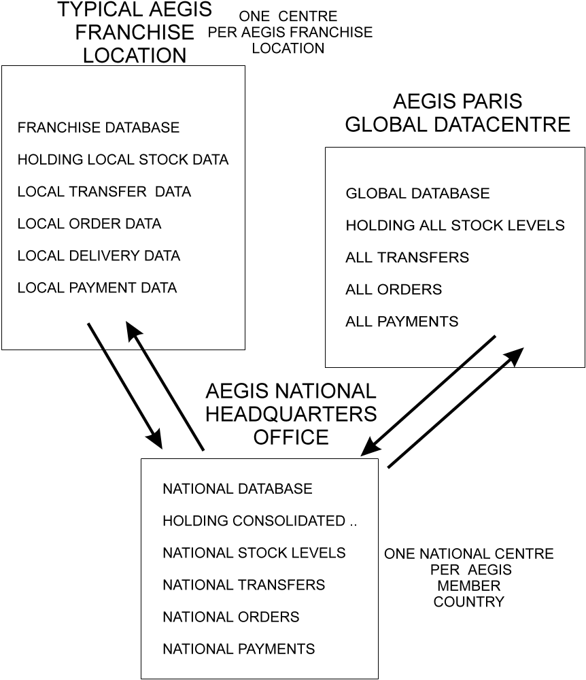
Notes to diagram: The National Warehouse holding overall stocks for each country is located close to the National Office for each country. Each franchise outlet holds only a small stock of items for display purposes and minimum stocks needed to satisfy normal order levels. Transfers of stock from the National Warehouse to franchise stockrooms, and between countries is performed automatically by TELMO. Customers ordering items will either have their orders satisfied through local stock or by transfers of stock initiated through TELMO.

Part 4: Legacy systems

Update on timetable
The project is eight months old, two months behind schedule and a special project meeting has been convened to discuss obstacles which have emerged. They fall into two categories:
- old accounting systems are proving difficult to handle;
- additional work and new requirements, keep appearing - some of these jobs almost seem like projects in their own right!

National accounting systems
The TELMO software package is installed, together with its telephone exchange equipment in three locations - the AEGIS National Centres in DUBLIN, COLOGNE and MADRID. The system is also up and running in AEGIS Paris - the designated global centre.
The ordering system is working as planned, but there are many problems with interfaces between TELMO and AEGIS’s various National Accounting systems.
A few of the problems can be summarised as follows:
- the generation of transaction data acceptable to the accounting programs have proved to be more complex than was anticipated:
- for example, the field types in transactions expected by the Spanish accounting system cannot be generated directly from TELMO - they are a throwback to the era in which the accounting system was written. This is compounded by the poorly documented nature of the system and the fact that the authors of the software are no longer employed within the Spanish Civil Service. A survey by the project team shows that other accounting systems may have similar problems;
- for example, the German system has recently been modified to deal with the Year 2000 problem and some of the dates have to be input with alphabetic characters. This is handled differently for different types of transaction. TELMO itself would have to be modified match this requirement;
- the treatment of VAT is handled very differently within different national accounting systems:
- for example, publications are VAT free in some countries but not in others;
- reciprocal VAT arrangements apply between European Union countries but not between others;
- and a legal question has been raised: - “where is the point of sale”. When orders are captured by one country for another and forwarded via TELMO there is the issue of which country made the sale. This is treated differently by different legal statutes within countries.

TELMO and the user
TELMO is showing itself to be a fine piece of software - it installed smoothly, it is robust and error free, and it has controlled the Erikson equipment and operators flawlessly. There is, however, one snag ..
TELMO has never been used before outside of the Swedish marketplace and therefore, naturally, all of the user instructions, keyboard engravings, and screen messages are in Swedish!
The designers have, however, thoughtfully gathered all of the user interface messages together in a single message library - so potentially they can be translated into any language of choice.
The language problems are not acute at AEGIS national centres where staff are often multi-lingual, but it will prove a problem at franchise outlets, where local staff cannot speak Swedish.
This is going to generate extra work for the project and cause FASTRAK to incur costs that had not been budgeted.
Although AEGIS Svenska is sympathetic to the problem they are not willing to fund the conversion costs.

More sub-projects
The outcome of the problems with TELMO is that two new sub-projects have emerged during that were not accounted for. They are:
- additional data modification and conversion programming needed for TELMO-to-National-Accounts systems interfacing:
- the AEGIS India programming team are stretched to capacity, and therefore additional programmers will need to be recruited to meet the project requirements;
- user interface and language translation is required before the franchise operators can successfully be trained in and use the TELMO system.

Problems with documentation
Marsha Yblonski, the Change Co-ordinator is having a difficult time. She receives reports from all key members of the project team. Unfortunately CONFIANCE, the project management methodology, does not prescribe standard formats for interface, problem and change reports. This is causing Marsha great difficulties in keeping up with events.
The difficulties with the accounting interfaces have brought home just how poor standards were, ten to fifteen years ago, when AEGIS organisations first created their accounts systems. In fact the overall documentation level available to the project team has been described as “appalling”.

Project tensions
The delays, long working hours, system interface problems, travel, language difficulties and extended stays of the project team in Paris are giving rise to tension amongst the team.
Arguments are more frequent and tempers get frayed. This in itself is proving counter-productive.
Two members of AEGIS Paris yesterday walked out of a project meeting when they felt they were being accused of not co-ordinating their aspects of the project properly.

Politics - a possible impact on funding
The British government has threatened to stop co-operating with AEGIS France unless the French government pays its overdue contribution to the project.

Project decisions
An extraordinary Project Board meeting convened to discuss these unforeseen events has decided that extra funding will have to be provided to overcome the obstacles to implementation of the system. The Project Board has invented a new title for these events it calls them “INVISIBLE PROJECTS” - these are the ones you didn’t know about at the time you commission a project.
The Project Board decides to continue the project, albeit at increased cost and at some time delay, because much of the infrastructure seems close to working. The TELMO Erikson equipment is performing well, and some networks are up and running properly. The first franchise AEGIS outlets are being fitted out now and the private sector is still enthusiastic about the partnership.

Revised project timetable
The official project launch date has been postponed by two months to allow for the extra work.

Revised costs
The budgeted costs of project FASTRAK rise by £8 million to £33 million.

Part 5: New technology

Update on timetable
Three more months have passed and further key decisions have had to be made.
- TELMO will is being interfaced as rapidly as possible to the accounts systems and where necessary certain order or transaction types will be dropped - these are the ones that are causing the greatest interface problems:
- this will reduce the functionality of the system when it first goes live.
- The missing elements of the system will be completed after the core of FASTRAK is operational using RAPID APPLICATION DEVELOPMENT techniques and tools. For two national systems this will mean re-writing their accounts system. For the remainder of the systems this will mean building extension modules to TELMO:
- this work will be done as a new project called “FASTRAK 2”.
TELMO has been successfully integrated with all the pilot systems involved in the first tranche of FASTRAK roll outs. The language translation into English, French, Spanish, German and Portuguese has been accomplished with resources commissioned from the European Union. This gives a reasonable platform for franchise operations in the first stages - as this group of languages is acceptable to 90% of the AEGIS franchise community.

Revised timetable
In spite of additional resources the project has been delayed by a further month due to reworking of part of the project when a member of the core team left abruptly.
The project at month eleven, is now three months behind the original schedule.
Tim Yoo, the project accountant has fallen ill, and schedules have not been circulated for some weeks. Marcel, the project manager, however, feels that they are not needed for the remainder of the project - as it is so close to completion.

Revised costs
The work on language translation has added £1 million to the cost of the project.
Unfortunately the network costs have also risen due to a need to install faster lines. This can be traced back to a decision by Allison Plum to opt for minimal services at the outset.
The data volumes generated and transmitted via TELMO have proved to be more than 100% greater than was originally estimated. This was due to an oversight.
At an early stage AEGIS decided to offer credit card processing, available via the TELMO package - but forgot that credit card purchases require advance authorisation from the VISA and MASTERCARD networks.
Credit card processing has caused TELMO to generate additional transactions for the VISA and MASTERCARD organisations, and these together with the return authorisations have double the data traffic in the FASTRAK network.
All in all this had added another £5 million to the costs of the hardware infra-structure of the project. It may also impact operational costs in the live system.
The projected project FASTRAK costs have now risen to £39 million from the original base of £25 million.

Difficulties with technology
There have been problems with the YASHOO Industries bar code reading system.
Apart from the delays in importing trial equipment into Britain it seems that there is now a bug in the bar code data capture routine that randomly produces garbage product codes.
This triggers errors, as these codes are not on the stock database, and it means that about 12% of the codes have to be re-entered by hand.
The bug appears to be a function of the angle that the bar code reader head is held at, relative to the bar code that is being scanned. This wasn’t spotted during early trials because a bench-mounted bar code scanner was used for the evaluation. In practice, in the franchises, all scanners will be hand held - and this will create wide variations in read angle and induce errors.
A solution has been found but it means that all the readers, now distributed for staff training, have to be recalled, returned to YASHOO Industries and modified. It shouldn't however, impose any more than two weeks delay on the project.
There is a further minor problem with the bar code scanners in that they seem to be badly affected by bright lights. Sunlight directly shining onto a bar code reader’s lens causes the scanner to generate false data. This problem emerged during a franchise training exercise in Madrid. A crude solution is to screen the area in which the equipment is being used, but a better long term solution will be sought as part of FASTRAK 2.

New blood in the team
It has become obvious that a multi national team working together on a major project must be properly co-ordinated. In many cases a team member working on one task had accidentally spoilt the work performed by a team member working on a different task. Change control across multiple projects is clearly more difficult than change control and co-ordination of a single project.
Marsha Yblonski, the change co-ordinator, who was new to change management, was clearly out of her depth on this project, and her efforts at co-ordination were ineffective.
So .. there is a new appointment: a Programme Director, and his name is Bill Matthews. This is what he has to say:
- “My name is Bill Matthews, we've not met before as this is my first progress meeting, but as we all know - the project has run into severe difficulties. So I'd better explain why I've been brought in to oversee Project FASTRAK and its sub-projects:
- There is nothing wrong in what anyone has done. But to take one case - let’s look at Allison Plum. Allison has been working extraordinary hours at franchise sites and desperately needed extra resources. But no-one was able to listen to her because they were so busy with their own part of FASTRAK;
- Allison will continue to be the networks manager and will still be responsible for co-ordinating the networking side of the project. But now that I’m here AEGIS is listening to her side of the story and we are now committed to providing her with additional resources;
- This is just one example but I can find others. We need a better way of co-ordinating all activities, otherwise we work at cross purposes with each other;
- From now on we must manage all the technical issues, user issues, software issues and partnership issues together - in short we need PROGRAMME MANAGEMENT;
- We’ve failed to do this effectively so far, and that is one of the reasons why we have stress and delay;
- During the remainder of this project - which we’re determined to make successful - we will use better techniques for cementing together the project infra-structure, for anticipating problems and risks - and most of all - by being ready with solutions by spotting the interface problems between sub-projects and doing something about them before they become problems”.

Part 6: Project roll out

Update on timetable
We are now in month sixteen, and FASTRAK has made great strides.
There have been no additional delays to the timetable, in fact the appointment of a Programme Director has already made its impact by improving dramatically the communication between teams. £1 million extra staff resources have also been given to the project. The first franchises are becoming operational.

Revised timing
The project is rolling out but overall the pilot franchises are four months behind the original schedule. This has angered some of the commercial partners, as they had hoped to be actively trading before now.

Revised costs
The project costs have stabilised and the revised budget of £40 million looks like being met.

Late but working
FASTRAK works! The TELMO system has been exceptionally robust, although the underlying networks have been less reliable than anticipated. This seems due to a co-ordination problem between telecommunications authorities from one country to the next. The reliability problem is being addressed, however, because national governments are pressing the telecommunications carriers for urgent action.
Staff who have been trained on the system are very impressed. User acceptance trials held in PARIS were a resounding success. The system was reported as being very user friendly in operation.
Even the bar code system, modified, by YASHOO Industries at its own cost proves effective in use. Hand keying of bar code data once running at a level of nearly 12% has now fallen to 0.1% of stock handling. All in all a good result!
A by product of the roll out of FASTRAK is that physical stock checks performed for the take-on of the system have revealed further enormous quantities of unwanted publications, in AEGIS National Centres,. A concerted effort - called project “Disposall” has been put in hand to clear out such dead material. FASTRAK is controlling stocks very tightly and it is likely that there will be a considerable pay back from this project in these terms alone.
Four national heads of government have visited AEGIS Paris to see the global centre in action and have expressed their ongoing support for the system. This includes the British government who have now withdrawn their threat of non co-operation!

The end of the project?
In spite of all the success one final problem has emerged - that of user training and support.
The strain on the FASTRAK team and the pressures at the middle stage of the project have resulted in inadequate preparations being made for end user use. Franchises and any staff not directly connected with FASTRAK are the worst hit. The problems are:
- delays in the project meant that user testing was performed only adequately - not all options were explored in depth...;
- .. this had a knock on effect in the training area where trainers training franchisees had only a bare grasp of the systems commercial-side operations and this in turn caused:
- a very high level of queries needing resolution from the help centres;
- inadequate user procedures manuals to be created;
- the accidental use of wrong options for entering transactions resulting in a high rejection and correction rate;
- the multi currency options of TELMO have proved a mixed blessing - as most franchise staff have little knowledge of this area, and frequently make mistakes - mistakes are trapped by the system but they then require a supervisor’s attention to clear the error - and this causes delays in operations.

Part 7: The aftermath

Update on timetable
It is two years after FASTRAK went live - and it is operating in 60 AEGIS member countries. More countries are being added each month. It is time to review the project! Using data in Parts 1 - 6 answer the following:
- TIME - did FASTRAK meet its time targets? - COSTS - did FASTRAK meet its budgets? - FUNCTION - did FASTRAK deliver its objectives?
- Using the following table data decide if FASTRAK met its performance requirements.

PERFORMANCE OUT-TURN FOR PROJECT FASTRAK - CALCULATIONS ARE ADJUSTED FOR NUMBER OF COUNTRIES PARTICIPATING
INDICATOR | KPI | YEAR 0 before FASTRAK | YEAR 1 - after FASTRAK | YEAR 2 - after FASTRAK
Value of Sales  -based on today | KPI-1 | £66m | £135m | £279m
Value of Sales  -predicted for FASTRAK- | KPI-1 | £66m | £180m | £427m
Value of Sales  -actual with FASTRAK | KPI-1 | £68m | £146m | £365m
Staff Costs - predicted | KPI-2 | £48m | £30m | £15m
Staff Costs - actual | KPI-2 | £54m | £22m | £8m
Order Turnaround times - predicted | KPI-3 | 23 | 6 | 6
Order Turnaround times - actual | KPI-3 | 23 | 12 | 7
Write off value - predicted | KPI-4 | £7m | £27m | £60m
Write off value - actual | KPI-4 | £6m | £8m | £2m

PROJECT LESSONS
- What did AEGIS learn about project management, and how could they pass these lessons on to future projects?
SUMMARY OF SUCCESS AND FAILURE
- What were the good points and the weaknesses on this project?

Part 8: The strike

Trouble at headquarters
Over the last few months civil servants employed by AEGIS, in common with the rest of the French civil service, have been in dispute with the French government. The dispute centres on long term arrangements for public sector pensions and withdrawal of social benefits.
Last week French air traffic controllers went out on strike disrupting all routes crossing France. The strike has escalated and now threatens to draw in the whole of the civil service.

The strike
One week later and the strike has spread. The dispute is proving insoluble and all parts of the civil service are now staging lightning strikes on a daily basis.
Computer centres are being targeted on a regular basis. These have been chosen to cause maximum disruption and embarrassment to the government.
Today AEGIS Paris Centre staff walked out and closed down all processing on the Global AEGIS system.
Pickets are surrounding the centre and there appears to be no date set for resumption of talks, let alone resolving the dispute.
The executive have held an emergency meeting and are faxing these instructions to AEGIS centres all over the world:
- “.. and because of the dispute .. regrettably the AEGIS Global operation is currently suspended. Whilst we have every confidence that normal operations will be resumed shortly we advise you to put into action your short term business resumption plans .. We will keep you updated on further progress as matters unfold, and assure you that we will do everything in our power to assist you to continue your operations in the meantime...”.

Operation of the AEGIS publication system
The AEGIS Global Publications system is an International Order and Delivery system.
Customers wanting AEGIS publications telephone a special number, in their home country, to place orders. This number connects them, at local call rates, to their National AEGIS centre, where a TELMO system is running.
The TELMO system passes the call to an operator who keys in customer order and payment details, and advises on stock levels, delivery times, and delivery options.
National centres are connected to National Stock Warehouse databases which record stock levels for publications, consolidated nationally.
TELMO will then transmit customer information, order and picking details to a stock centre closest to the customer’s address. Where a publication is not available locally TELMO will either arrange for the publication’s transfer to local stock from another stock location, or, alternatively, find another stockist who has the publication in stock and arrange for order fulfilment from there.
If a customer makes a call outside of normal working hours then TELMO will automatically link their call to the nearest manned AEGIS National centre. Such activities will be invisible to the customer who will think they are making a local call. Calls handled by one National Centre on behalf of another are automatically transmitted to the correct National centre by TELMO and will be waiting for staff when they arrive for duty on their next working day.
Data captured through an AEGIS National Ordering Centre via TELMO updates the local stockist’s TELMO system’s database, and vice versa. This is done in real time via network connections between AEGIS local and AEGIS national centres.
A global database of all operations is maintained at the headquarters of AEGIS in Paris. This is updated from AEGIS National systems and presents a consolidated picture of AEGIS operations world wide. It is also the Paris consolidated data system that arranges for cross payments between member countries for sale of their publications.
The only extra processing that is required at AEGIS locations is maintenance of stock and it is here that a bar code operation comes into play. Bar coding deals with:
- capture of customer order data, via the picking lists, output from the TELMO system:
- this generates both items to be picked;
- and data for fulfilment of delivery - such as an address label, packing or shipping instructions;
- capture of physical stock data from storerooms at each franchise location and input of this to the TELMO system for stock level reconciliation via the point of sale tills.

THE INTERNATIONAL AEGIS NETWORK
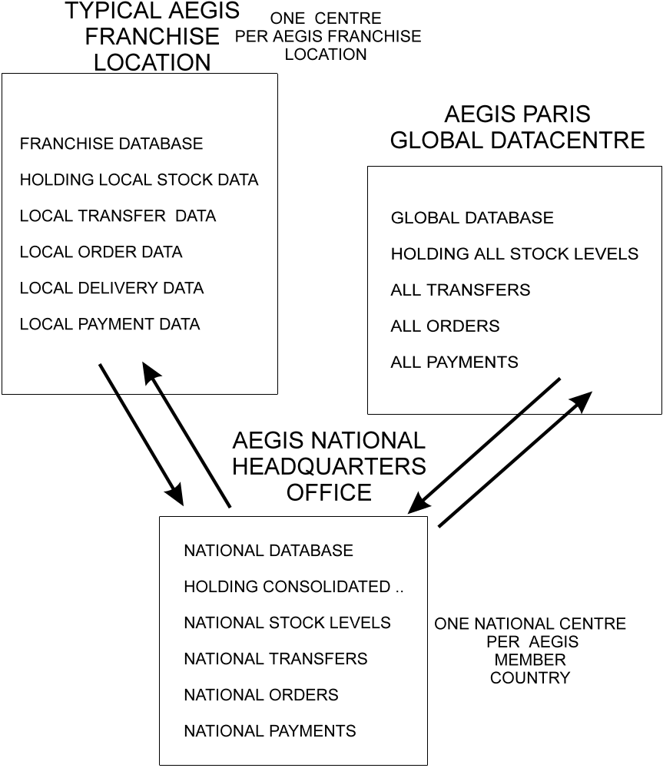
Notes to diagram: The National Warehouse holding overall stocks for each country is located close to the National Office for each country. Each stockist holds only a small stock of items for display purposes, and the minimum stocks needed to satisfy normal order levels. Transfers of stock from the National Warehouse to local stockrooms, and between countries is performed automatically by TELMO. Customers ordering items will either have their orders satisfied through local stock or by transfers of stock initiated through TELMO.

Business continuity planning
In order to cope with disruption to systems it is essential to be able to see risks that surround the system.
Business resumption planning is about being able to identify ways of maintain services in the face of short term problems which deny access to systems or facilities.
There are four elements that are important to any business resumption plan:
- plans for systems - for example:
- what do you need?
- what can you manage without?
- plans for support to systems - for example:
- can you cope without a network?
- can you cope without technical support?
- plans for people - for example:
- where are they going to work?
- what can they do?
- plans for data - for example:
- how can we continue to capture data?
- how do we ensure the integrity of the data after normal services are resumed?

Asia - European Government Issuers of Standards
this will vary from country to country
in the UK, for example, there are six shops open to the public
with the exception of Japan which has an automated system
“AEGIS - The Road Ahead”
funding for this was agreed at the Spring 1996, Aegis conference in Madrid
the Committee of Directors, International AEGIS
this is in part in response to pressure by member governments to reduce the overall £675 million subsidy that AEGIS receives
Figures for the UK are available in the National Audit Office report: “Aegis UK - 1993”, ISBN 0-34-519787-1
AEGIS Japan uses YASHOO bar coding equipment in its shops
transfers of stock at present are based on bulk packaged publications, individual items cannot be transferred
based on their earlier work
see ANNEX - 1 to this section
see ANNEX - 2 to this section
Projects IN Controlled Environments
TELMO - TELephone based Mail Ordering
this work will be done by the programming team from India
this are the lists of items ordered that are to be assembled from stock for despatch to a customer
Audit Office of Spain, report “AEGIS - Project FASTRAK - a review” , Section 11 “Documentation and the team”
AEGIS - the Asia-European Governmental Issuer of Standards
TELMO - TELephone based Mail Ordering - this is software that controls telephone exchange equipment and telephone operators and captures customer orders for fulfilment
picking details are lists of goods to be taken from stock for a customer order
this will be a frachise outlet selling AEGIS publications

